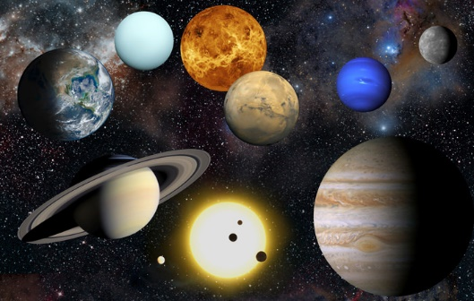
We are excited to announce our overnight trip this year will be to Astrocamp in Idyllwild, California May 15th- May 17th, 2023!
Astrocamp is an outdoor science school program that is designed to give students an experience that will stay with them for the rest of their lives. Students will explore the sciences of physics and astronomy, develop as individuals, and foster their sense of wonder. Please visit https://astrocamp.org/ to check it out.
We will travel by charter bus to the camp on May 15th and return on May 17th. The cost for each student will be $460.00. Please look for more information coming out soon via email from the office about payment options.
We will select eight chaperones in a lottery on January 16, 2023. Chaperones pay a $300.00 chaperone fee. Please look for the chaperone request form in the coming weeks.

